 PRESERVE A MEMORY AT A PARK IN CLINTON, IOWA

Clinton Parks and Recreation offers four meaningful opportunities to give a gift and make an impact on the Clinton Parks. Give a gift of shade, a place to rest and enjoy the park or mark a memory with a brick or plaque. With several options for giving, you can help to make our park system and city an even better place to live and play! There are various locations in all of our parks to preserve your memory in Clinton, Iowa.

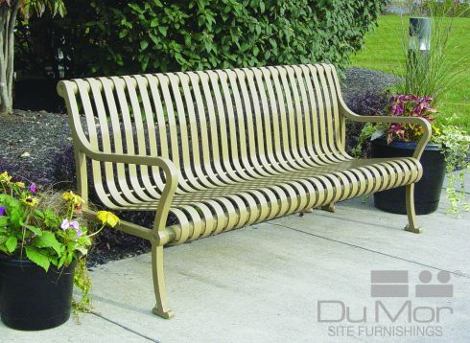**Park Bench**The bench is pictured below. The bench will be installed on a concrete slab at the selected location. The bench can be ordered with a customized plaque and/or an arm rest for the middle.   
If bench if located in Riverview Park, the color will be tan or if located in other parks, it will be a deep red color and will stand the test of time.   
All benches include installation, freight and concrete pad.

**Plant a Tree**

Give a gift of a tree. There is a master list of approved trees and locations available. Coordination between Public Works and the local nursery is required. Once tree is approved along with location, customer purchases tree and pays for installation.   
Reminder, trees require water and in most parks, water is not available unless if comes from the sky.

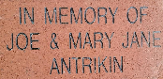**Customize a Brick** Your brick will be displayed in the pathway leading up to the entrance of the Eagle Point Lodge in Eagle Point Park for years to come or at Lubber’s Fountain in Riverview Park along the Mississippi River. 4”x 8” brick- 3 lines up to 13 characters per line and BLOCK lettering. Did you have your wedding or a special event at the Lodge or have special memories along the River? Have that date etched in stone and on display for years to come.

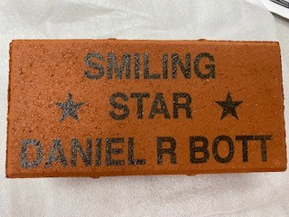

______ Customized Brick $100 (4”x 8”) - up to 3 lines

______ Park Bench $2,400

_______ Add an Arm Rest to middle of Bench $135

_______ Add Plaque to Bench $370 (4” x 6”) - up to 6 lines depending on verbiage

_______ Plant a Tree $300 for location. Does not include the price of the tree and installation.

$______ to support Clinton Parks and Recreations efforts in continuing a great parks system.

Brick 4”x 8” up to 3 lines - Print one letter in each box

Name __________________________________________

Address ________________________________________

City, State, Zip ___________________________________

Phone (_____) __________- _____________

Email ___________________________________________

|  |  |  |  |  |  |  |  |  |  |  |  |  |
| --- | --- | --- | --- | --- | --- | --- | --- | --- | --- | --- | --- | --- |
|  |  |  |  |  |  |  |  |  |  |  |  |  |
|  |  |  |  |  |  |  |  |  |  |  |  |  |
|  |  |  |  |  |  |  |  |  |  |  |  |  |

Plaque 4” x 6” up to 7 lines - Print one letter in each box

|  |  |  |  |  |  |  |  |  |  |  |  |  |
| --- | --- | --- | --- | --- | --- | --- | --- | --- | --- | --- | --- | --- |
|  |  |  |  |  |  |  |  |  |  |  |  |  |
|  |  |  |  |  |  |  |  |  |  |  |  |  |
|  |  |  |  |  |  |  |  |  |  |  |  |  |
|  |  |  |  |  |  |  |  |  |  |  |  |  |
|  |  |  |  |  |  |  |  |  |  |  |  |  |
|  |  |  |  |  |  |  |  |  |  |  |  |  |
|  |  |  |  |  |  |  |  |  |  |  |  |  |

_____ check box confirming spelling on brick and plaque

Park for installation _______________________________

Location in Park __________________________________

________________________________________________

Paid $_____________ Date ___________ Cash/CC/Check  
Check made payable to Parks and Recreation

Date installed:____________________________________

Mail completed form and payment to: Parks and Recreation 1401- 11th Ave North - Clinton, IA 52732 563-243-1260  
Email completed form or questions to: cathymarx@cityofclintoniowa.us